What message did you receive? How would you fix this?
The local print spooler service is not running. Fix is to start spooler again or restart the computer.

When DHCP Client stops, what other services will also be stopped?
WLAN AutoConfig, Windows Connection Manager, IP Helper, WINHTTP Web Proxy Auto-Discovery Service

Why is it important to exercise care when managing services?
You can take down service that is needed by other systems to function.

What is the full path name to the example file name?
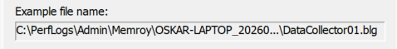

What does the column farthest to the right show?
Wasnt getting the right file format (I was getting .blg not csv)

